**Hands on 1**

**Create a Spring Web Project using Maven**

**STEP 1:**

**We will be doing this in intelliJ**

1. Go to <https://start.spring.io/>
2. Change Group as “com.cognizant”
3. Change Artifact Id as “spring-learn”
4. Select Spring Boot DevTools and Spring Web

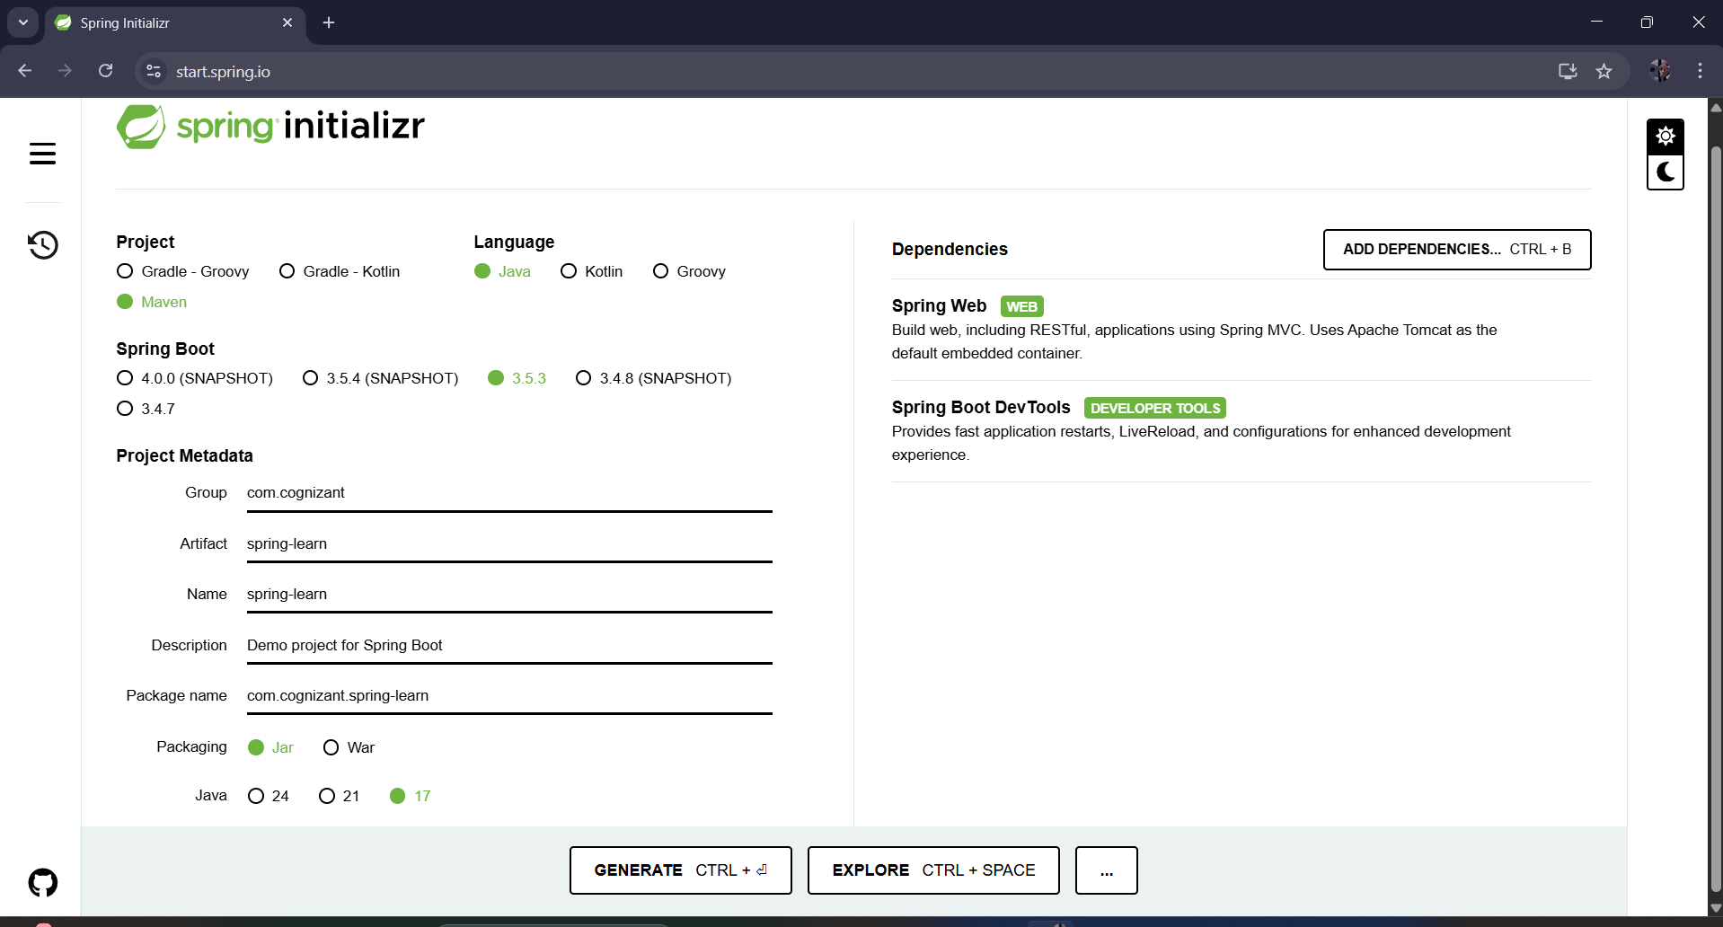

**STEP 2:** Include logs to verify if main() method of SpringLearnApplication.

package com.cognizant.spring_learn;

import org.slf4j.Logger;

import org.slf4j.LoggerFactory;

import org.springframework.boot.SpringApplication;

import org.springframework.boot.autoconfigure.SpringBootApplication;

@SpringBootApplication

public class SpringLearnApplication {

private static final Logger LOGGER = LoggerFactory.getLogger(SpringLearnApplication.class);

public static void main(String[] args) {

LOGGER.info("START: SpringLearnApplication");

SpringApplication.run(SpringLearnApplication.class, args);

LOGGER.info("END: SpringLearnApplication");

}

}

**STEP 3:**

src/main/java

* Contains your application code:
  + Controllers like HelloController, CountryController
  + Services like CountryService
  + Models like Country.java

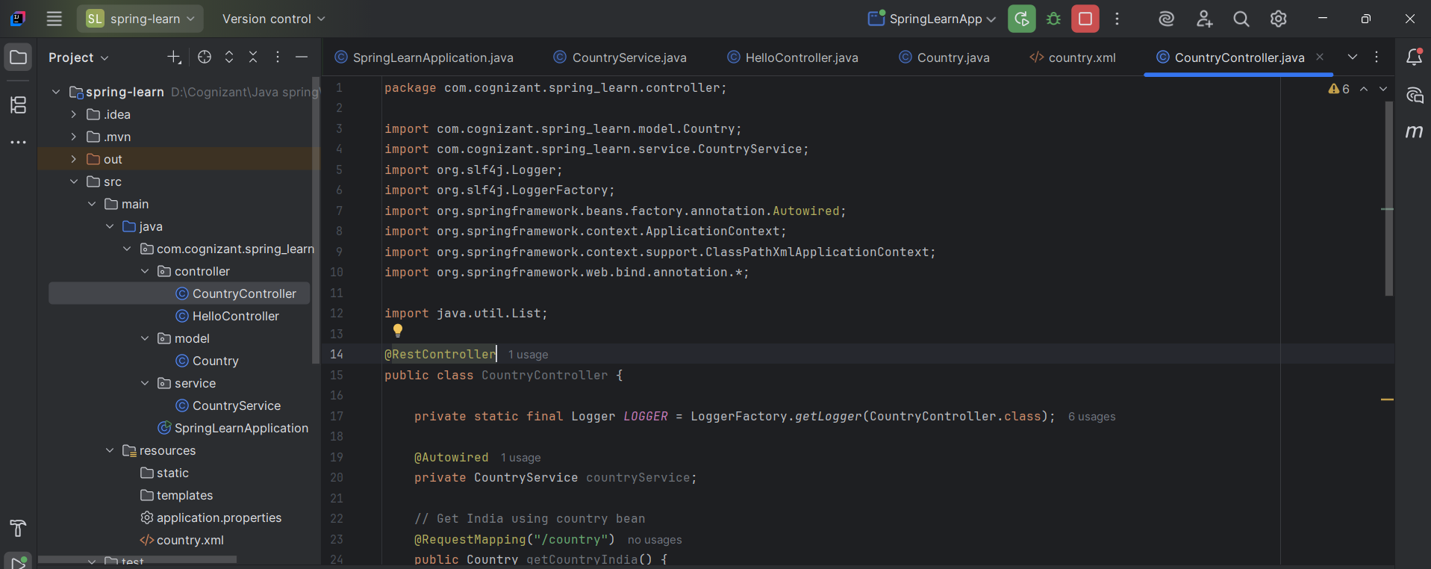

**STEP 4:**

src/main/resources

* Contains application configuration:
  + application.properties — sets port or logging
  + country.xml — Spring XML bean configuration

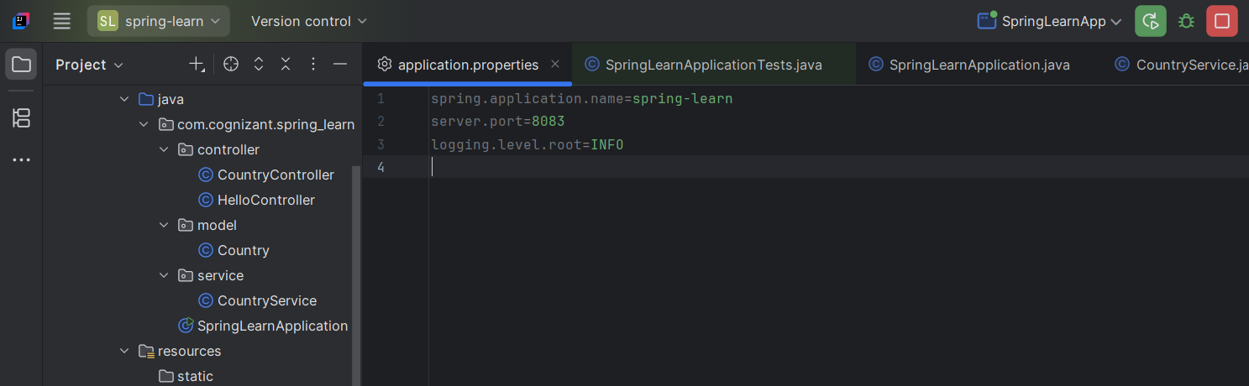

**STEP 5:**

src/test/java

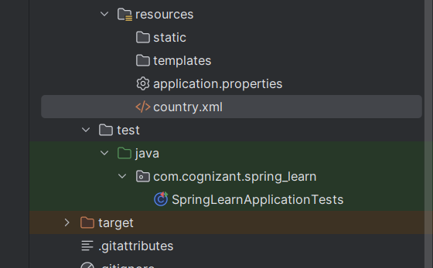

**Purpose of @SpringBootApplication**

* Meta-annotation that combines:
  + @Configuration (for bean config)
  + @EnableAutoConfiguration (auto-loads Spring features)
  + @ComponentScan (scans com.cognizant.spring_learn for components)

**STEP 6:** **pom.xml**

**STEP 7: Dependency hierarchy:**

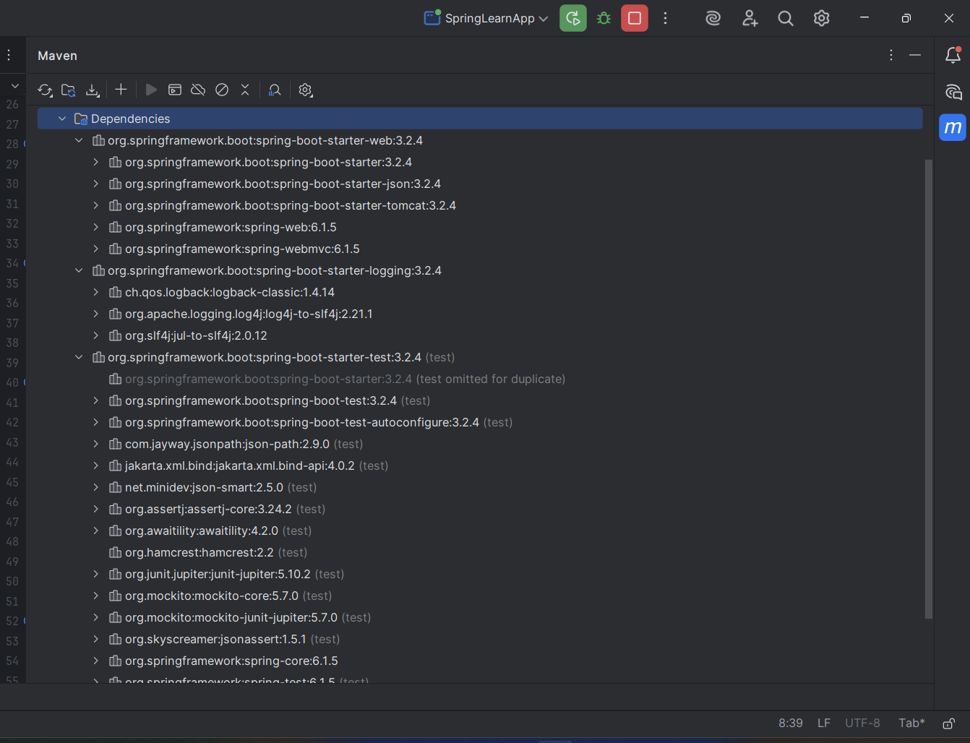

**STEP 8: Run and Validate**

**OUTPUTs:**

